# **How to set up property values in property files?**

1. Open CXC.ClaimXO.Properties.props in notepad++
2. EnvironmentName🡺 Name of target environment. (it may be Production or QA) this is optional property because we are going to set this property via command line argument.
3. SVNRepostitoryURL 🡺 SVN Repository URL (e.g. <https://svn.cxcnetwork.com/svn/CXCcore/branches/TestBuild>)
4. SvnUsername 🡺 Your SVN username
5. SvnPassword 🡺 Your SVN password
6. So far we did set those properties values which are common for all environment.
7. Now we will set up property value based on Environment name
8. SourceDir🡺 File system location where you want to download source code. (this property can be considered common for all environment)
9. LocalPathToSaveBuildCode 🡺 File Location where you want to save your build code.
10. DatabaseBackupPath 🡺 File Location where you want to save your database backup (i.e. local path or server location where your database is hosted)
11. TargetPathToPublishCode 🡺 File location where you want to publish code. (i.e. local path or server location where your server code is hosted)
12. SqlInstance 🡺 Sql server instance name
13. SqlUserName 🡺 sql server username
14. SqlPassword 🡺 sql server password
15. DatabaseName 🡺 database name
16. EmailAddressToReplace 🡺 Most of the cases it will be [alerts@cxcnetwork.com](mailto:alerts@cxcnetwork.com)
17. ReplaceWithEmailAddress 🡺 If it is QA environment then it will be QA email address which will be replaced with EmailAddressToReplace property value.
18. EnvironmentName 🡺 The value which you want to set as environment name. (e.g. ManojDev)
19. FTPPath 🡺 Location of FTP folder. This value will be set into CoreParams.xml
20. StagingPath 🡺 Location of staging folder.
21. ArchivePath 🡺 Location of archive folder.
22. UpdateAssemblyVersion 🡺 Set value true, if you want to update assembly version else set value false.
23. IsBuildGDI 🡺 set true if you want to build GDI solution
24. IsBuildPrimePay 🡺 set true if you want to build PrimePay solution
25. IsBuildPayFlex 🡺 set true if you want to build PayFlex solution

# **How to run MSBuild script**

1. Open MSBuild command prompt on your local system.
   1. MSBuild.exe can be found on following path (it depend on which visual studio version is installed on your system)
      1. C:\Program Files (x86)\MSBuild\12.0\Bin\MSBuild.exe (If VS2013) **OR**
      2. C:\Program Files (x86)\MSBuild\14.0\Bin\MSBuild.exe (If VS2015)

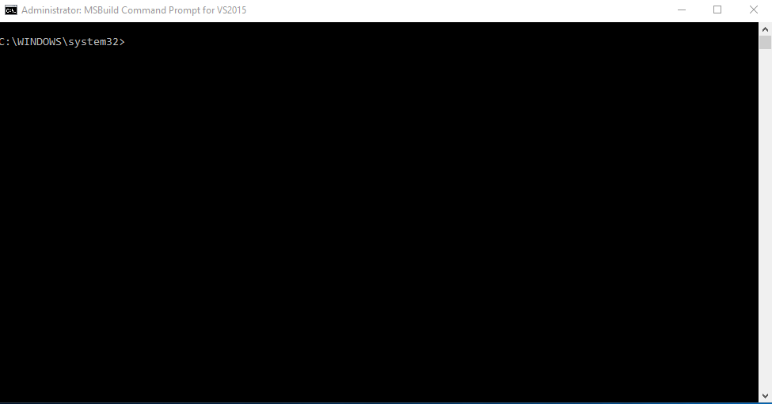

1. Extract attached zip file into your local system.
2. Navigate to your local system path where “CXC.ClaimXO.Build.proj” is located on command prompt.

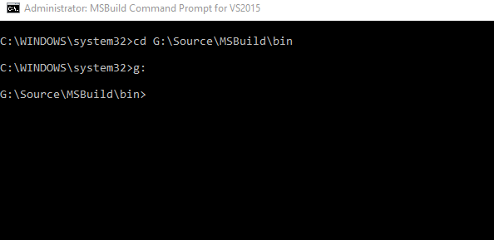

1. Run following command
   1. If Target System is production
      1. msbuild CXC.ClaimXO.Build.proj /p:TargetEnvironment="Production"
   2. If Target System is production
      1. msbuild CXC.ClaimXO.Build.proj /p:TargetEnvironment="QA"

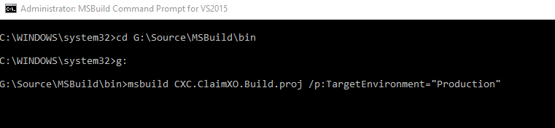

1. Above command will start executing MSBuild script.